# Final Report

FITNESS CLUB

**Section : K19HA Group : 1**

# Internet Programming Laboratory (CSE 326)

By

|  |  |  |  |  |
| --- | --- | --- | --- | --- |
| Sr. No. | Registration No | Name of Students |  | Roll No |
| 1 | 11916434 | Ritesh Kumar | 04 |  |
| 2 | 11915764 | Abhishek Kulla | 05 |  |
| 3 | 11915263 | Aditya Raj | 06 |  |



## Submitted to Miss. Manu Bali

Lovely Professional University Jalandhar, Punjab, India.

# Declaration

We hereby declare that the project report entitled “**Fitness Club**” is submitted by our team for partial fulfilment of requirements for the award of degree in **Bachelor of Technology in Computer Science and Engineering** to Lovely Professional University, this is our original work and has been completed under the guidance of our **Professor Miss Manu Bali**.

# Acknowledgement

Our team would like to thank our **Professor**

**Miss Manu Bali** for assigning this task of creating a website on ***Fitness Club***, she provided us guidelines for developing this website. Also, our team work lead us to this successful project.

# Table of Content

|  |  |  |
| --- | --- | --- |
| **Serial**  **number** | **Name of the pages** | **Page number** |
| **1.** | Introduction |  |
| **2.** | Problem  Description & About HTML and CSS |  |
| **3.** | Charts :-  (Gantt Chart and Work Breakdown) |  |
| **4.** | Functionality |  |
| **5.** | Bibliography |  |

# Introduction

A **Fitness club** (also known as a fitness club, fitness center, health spa, and commonly referred to as a gym) is a place that houses exercise equipment for the purpose of physical exercise. **Alan Smithee** describes a health club as a "company providing people, access to controlled environmental condition space and services focused on physical fitness and health in exchange of a fee."

# Problem description

We got a project to make a Fitness website. Problem we got are as follows:

1. **How to approach?**

Ans :- So we all 3 team members discuss about structure and design regarding our webpage and we decided to make our site very lite and simple so that everyone one can easily navigate. So, we designed some rough designs on papers of our webpage and started our work by distributing works to each other.

1. **Difficulties during making webpages?**

Ans :- When we all started making our webpages we smoothly did our HTML part, but when we come to CSS we are now getting stuck after some steps because we are doing it first time. But thanks to our *Prof. Manu Bali* *Ma’am* they had teach us well and also told us we will encounter many new codes at the time of making project and exactly that happens. We started finding it hard to make webpages as same we design on paper before so we started studying more and digging more about CSS and we learn more code and property from a very famous site W3school from there we learned many things and it help us a lot in learning CSS. We generally searched for a way how to do this and study that and then apply that thing in our projects.

About HTML:

Hypertext Markup Language (HTML) is the standard markup language for documents designed to be displayed in a web browser. It can be assisted by technologies such as Cascading Style Sheets (CSS) and scripting languages such as JavaScript.

Web browsers receive HTML documents from a web server or from local storage and render the documents into multimedia web pages. HTML describes the structure of a webpage semantically and originally included cues for the appearance of the document.

HTML elements are the building blocks of HTML pages.

About CSS:

Hypertext Markup Language (HTML) is the standard markup language for documents designed to be displayed in a web browser. It can be assisted by technologies such as ***Cascading Style Sheets (CSS)*** and scripting languages such as JavaScript.

Web browsers receive HTML documents from a web server or from local storage and render the documents into multimedia web pages. HTML describes the structure of a web page semantically and originally included cues for the appearance of the document.

HTML elements are the building blocks of HTML pages.

About JAVASCRIPT:

**JavaScript** often abbreviated as **JS**, is a programming language that conforms to the ECMAScript specification. JavaScript is high-level, often just-in-time compiled, and multi-paradigm. It has curly-bracket syntax, dynamic typing, prototype-based object-orientation, and first-class functions.

Alongside HTML and CSS, JavaScript is one of the core technologies of the World Wide Web. JavaScript enables interactive web pages and is an essential part of web application. The vast majority of websites use it for client-side page behaviour, and all major web browsers have a dedicated JavaScript engine to execute it.

Charts:

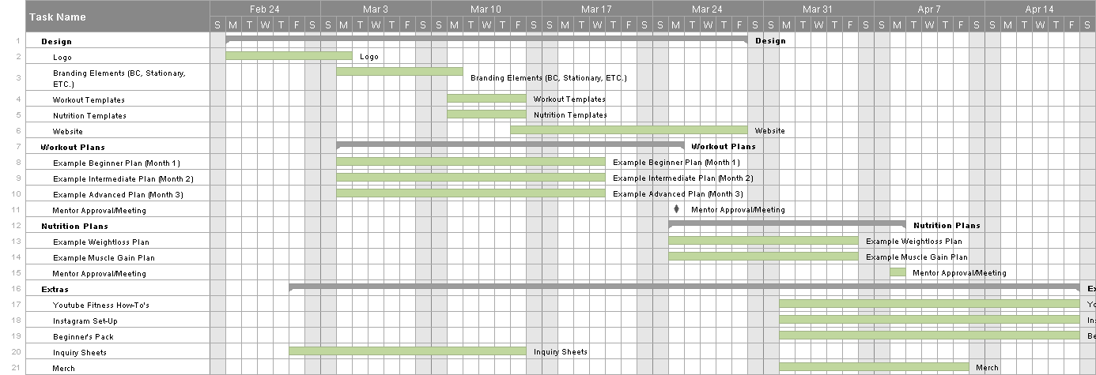1)Gantt Chart

2)Work Breakdown Chart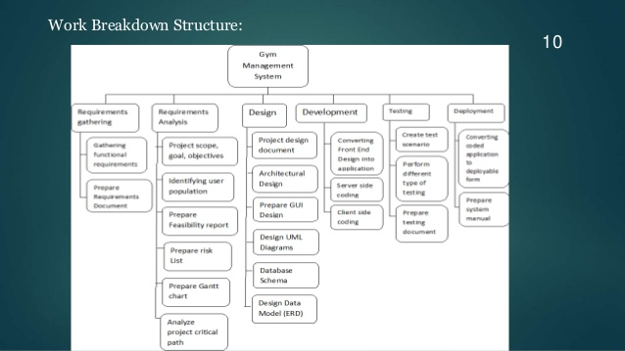

# Output Of Home Page:

1.Header

2.Home

3.About

4.services

5.our classes

6.start today

7.class schedule

8.workout gallery

9.price

10.contact

**SITE CONTENTS:**

1.HEADER

Home,about,services,classes,schedule,price,  
contact

2.HOME

It's gym time,let's go

we are ready to fit you

learn more/ join now

3.ABOUT

>best training

>free consultation

>build perfect body

4. SERVICES

Start now

>cardiovascular Equipment

>Strength Training Equipment

>Group Fitness Class

>Other services

5.CLASSES

>Price

>strecthing Training

>Details

6.START TODAY

>start your training today

>start now

7.CLASS SCHEDULE

Day,Time,exercise name,Room number

8.GALLERY

>images

9.PRICE

>price>???/-per month

>image

>heading>Body building technique

Get free wifi

month to month

No time restrictions

gym and cardio

service locker rooms

JOIN NOW!

10.CONTACT

left side>form

right side>get connected with gym

address>

mobile>

mail>

social links:

# Functionality:

1.Home Page:



2.Home page with taskbar:



3.About our club:

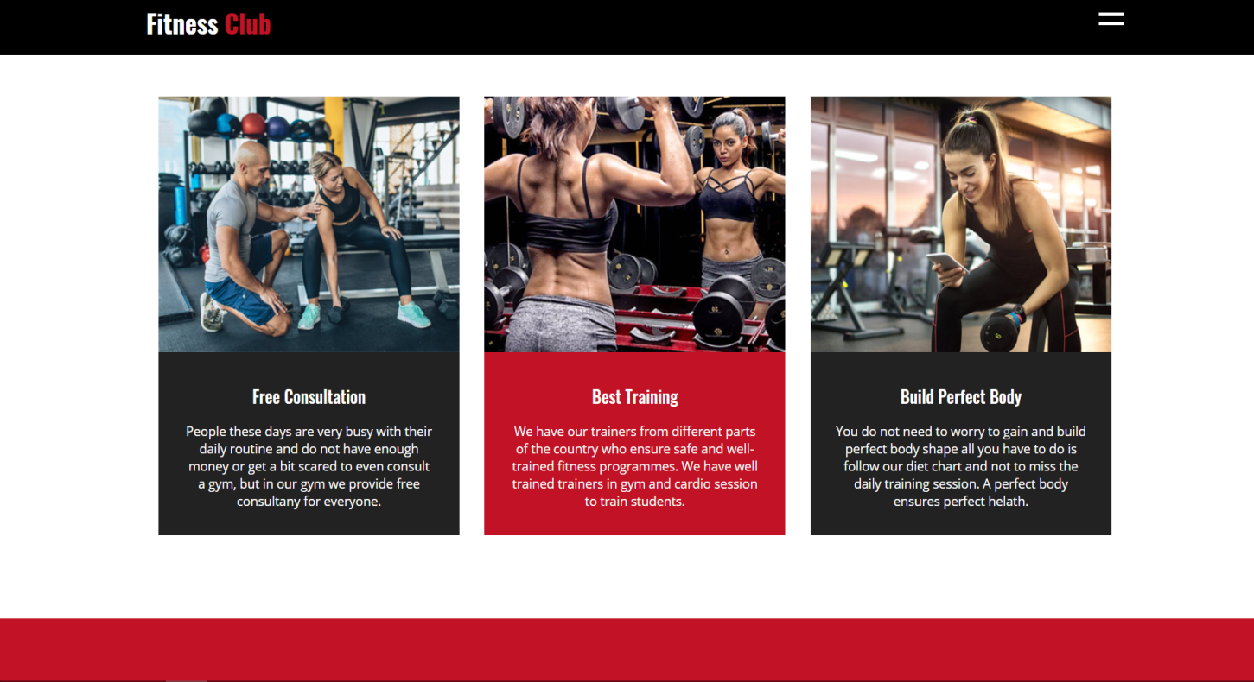

4.Services:

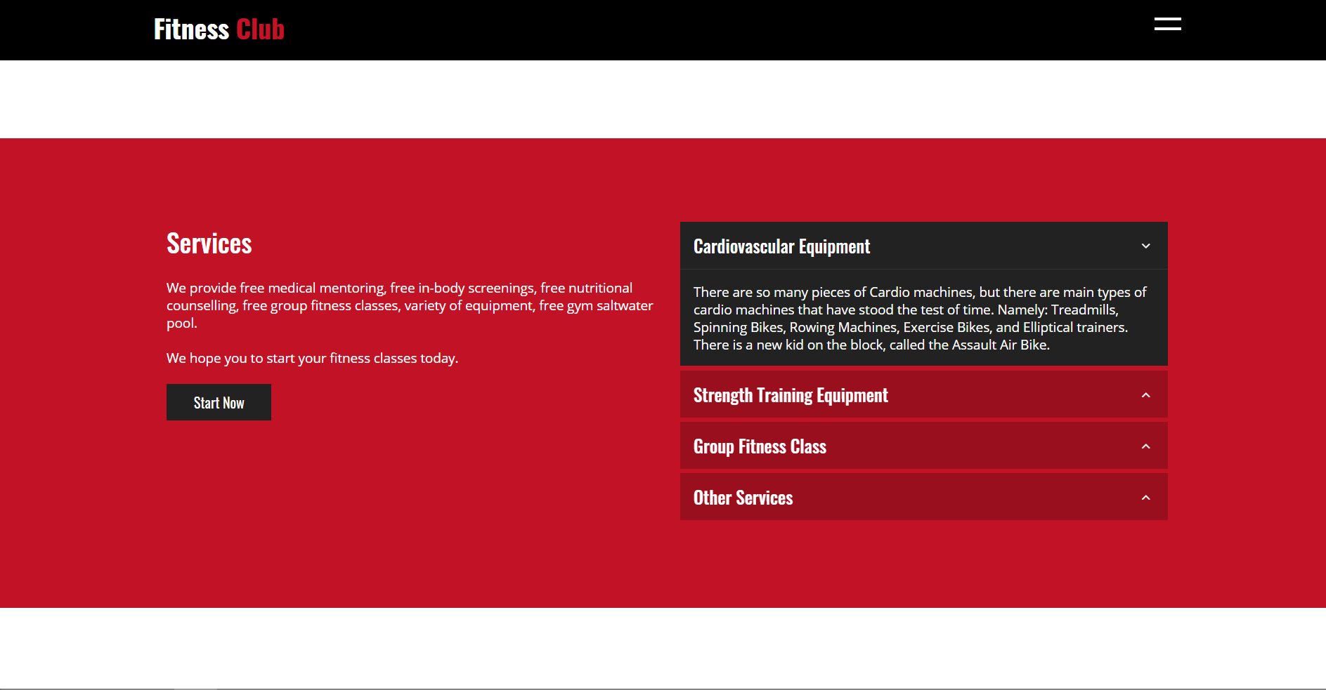

5.Our Classes:

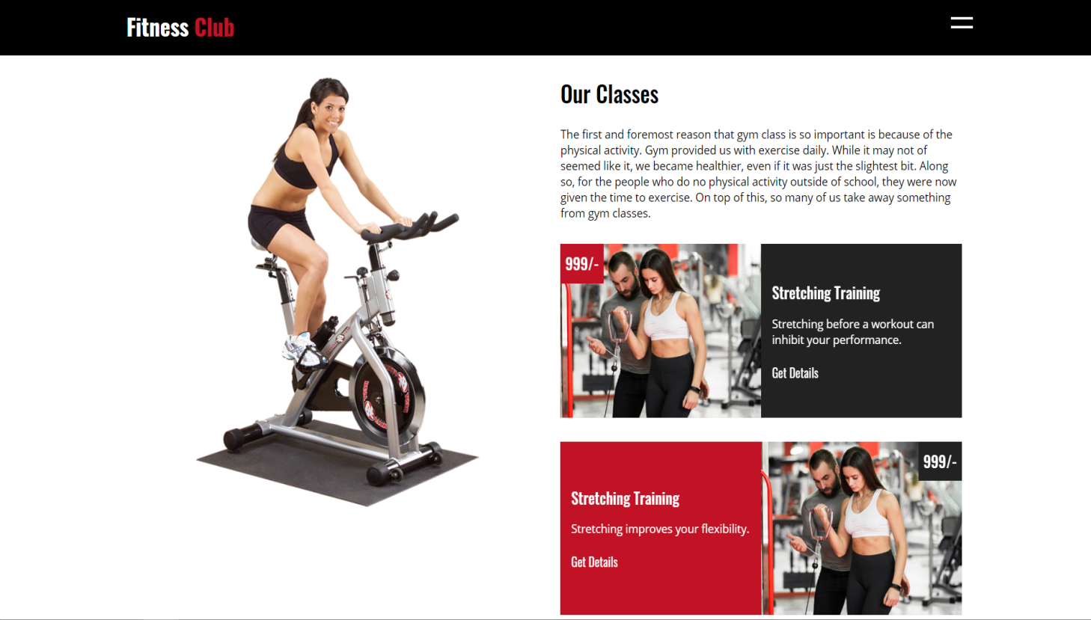

6.Class Schedule:

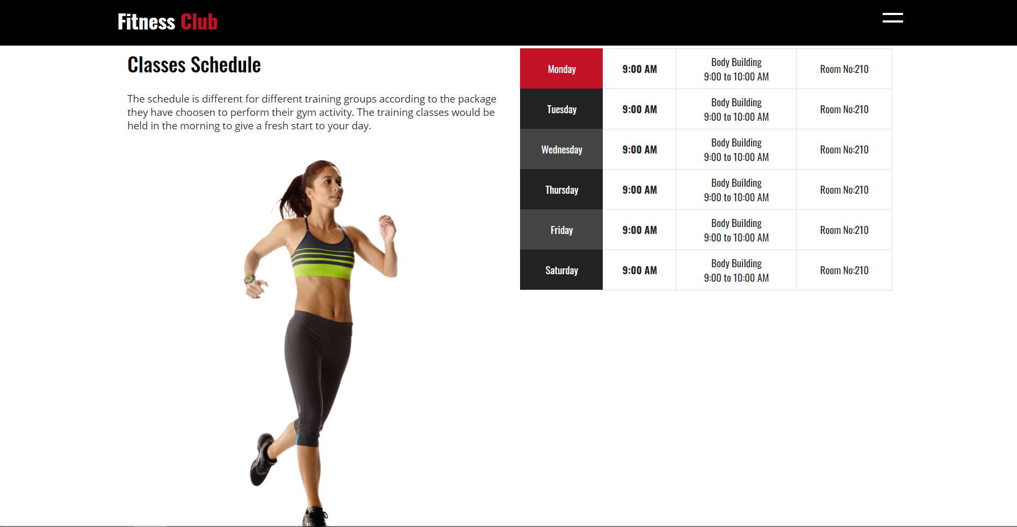

7.Workout Gallery:



8.Our Packages:

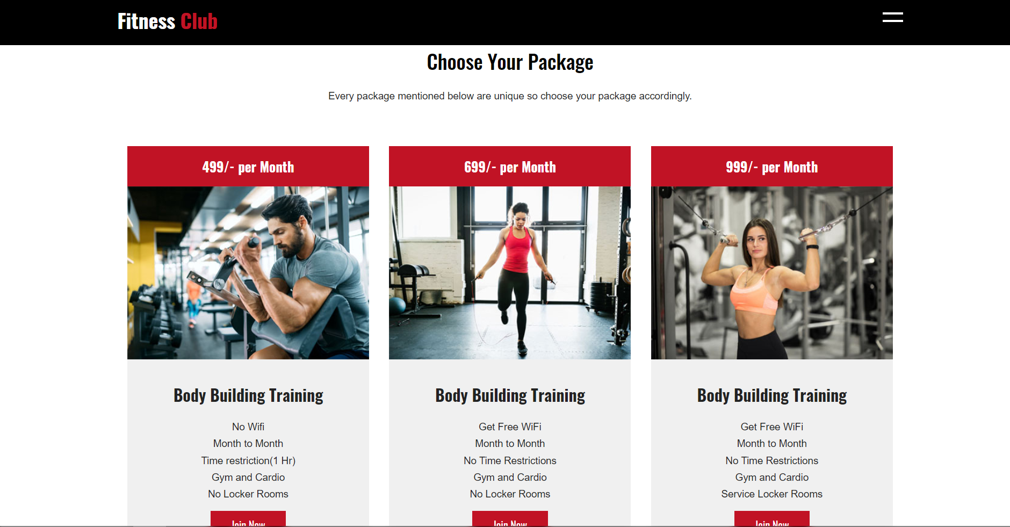

9.Contact or Helpline Page:

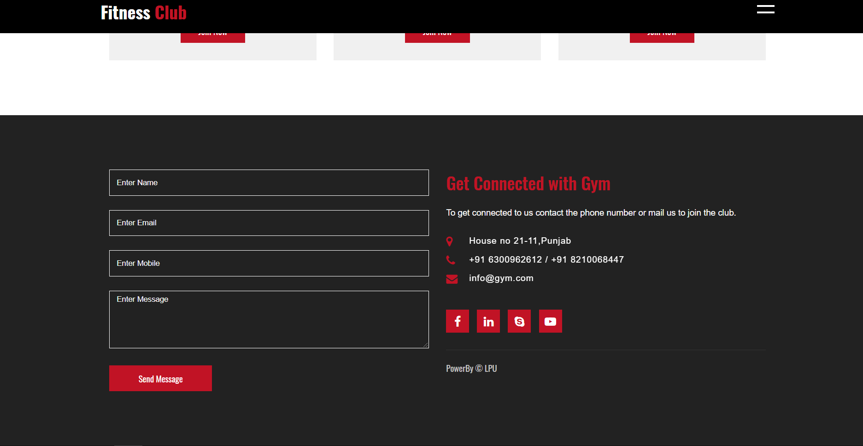

This is the Ad-page we have created regarding our

topic “FITNESS CLUB”. And the images above are our Ad-page pictures and output.

## Bibliography

1. www.w3schools.com
2. Wikipedia
3. HTML 5, CSS, JAVASCRIPT by Krogent Learning, Dreamtech Press.